MLK Food Drive 2024 Media Toolkit

When | Tuesday May 7, 2024-Tuesday May 21, 2024
Where | All Quad Cities and surrounding area Hy-Vee stores, ALL Quad Cities Libraries, GiGi’s Playhouse, Rock Island Parks and Recreation locations, Davenport Parks & Recreation locations, Hand in Hand, Individual Advocacy Group, Empowering Abilities, QC Flex, and The Arc building.  See full list below.
What | Look for food boxes at participating locations
Why | In honor of Martin Luther King Jr.’s legacy to address food insecurity, and showcase the impact of inclusive volunteering.

Mission
Dr. Martin Luther King Jr.'s timeless words echo with relevance: "Darkness cannot drive out darkness; only light can do that.” The Arc answered that call and hope you will help be the light. Each year, Americans nationwide shine bright to uplift their neighbors and communities. MLK Day stands as a beacon of this collective spirit, honored as the sole federal holiday dedicated to national service. It summons individuals from diverse backgrounds to collaborate in addressing our society's most pressing challenges.
The MLK Day of Service embodies empowerment, community fortification, and the breaking down of barriers, in pursuit of Dr. King's vision of a "Beloved Community." Through tangible actions and heartfelt contributions, participants not only alleviate immediate needs but also nourish the soul, offering hope amidst adversity.
In today's America, over 16 million of our most vulnerable citizens grapple with food insecurity, underscoring the imperative for community-driven solutions. Addressing this crisis not only ensures equitable access to nourishment but also fosters communal resilience and solidarity.
The Quad Cities Disabilities Awareness Coalition champions the rights and contributions of individuals with intellectual and developmental disabilities and their families. Recognizing the wealth of talent within this community, we affirm their capacity to enrich society and give back in meaningful ways.
Provided by the Corporation for National & Community Service and in partnership with the QC Disabilities Awareness Coalition, The Arc of the Quad Cities is proud to be part of the MLK Food Drive, championing inclusivity and empowerment. This project is an opportunity to redefine the capabilities of individuals with disabilities when given the chance to serve. It underscores the fundamental truth that we all thrive when we extend ourselves in service to others.
Written and Spoken
These are points that we should consistently talk/write about during the MLK Food Drive.
Our goal for the Martin Luther King Jr. Food Drive is to support individuals with disabilities to give back to their community while addressing food insecurity. These individuals will be picking up and helping to redistribute donations to local food pantries.
Mention your organization is a part of the Disabilities Awareness Coalition. You should mention a few drop-off locations that your organization is covering, the dates of the MLK Food Drive (May 7 – 21), and how to access the list of drop-off locations via https://arcqca.org/mlk-day-of-service/.
The Quad Cities Disabilities Awareness Coalition is a volunteer group dedicated to raising awareness and increasing the inclusion of people with disabilities in the Quad Cities. This project offers solutions to addressing food insecurity through inclusive volunteer programs at this critical time and creates a more welcoming and equitable community for everyone. The Disabilities Awareness Coalition is creating new community partnerships and increasing the community’s ability to reach new service areas.
Social Media
Delivering cohesive social media posts will not only highlight the diverse participation in the food drive but also foster a sense of unity among our partners, amplifying our collective impact and engagement with our audience.
Hashtags
Facebook and Instagram – please use #MLKDayofService (The MLK Day of Service Grant follows this hashtag) and #QCDAC (Allows us to easily locate and repost each other’s content, whether in Instagram Stories, Facebook Reels, or posts on any platform.)
Posts
See links below for informational images formatted for Facebook and Instagram with each members’ logo. We also have additional post borders that you can add your own images.
Examples of Social Media Posts
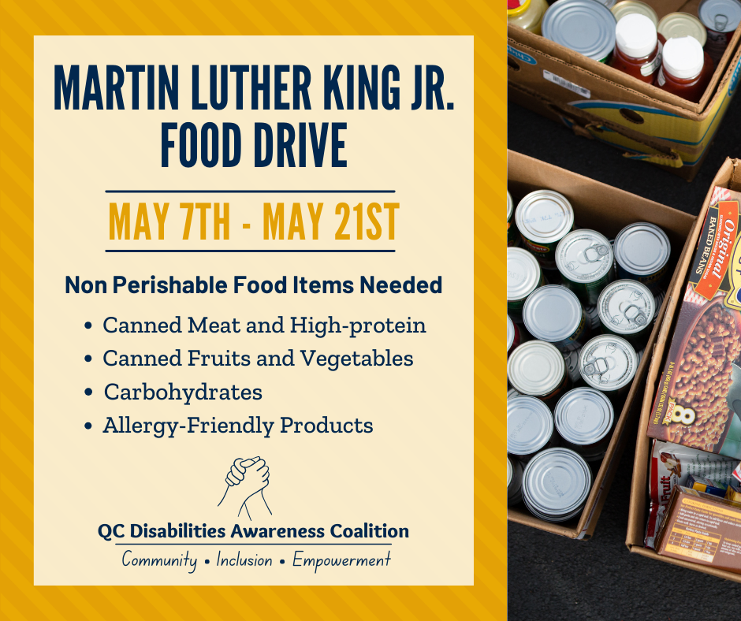 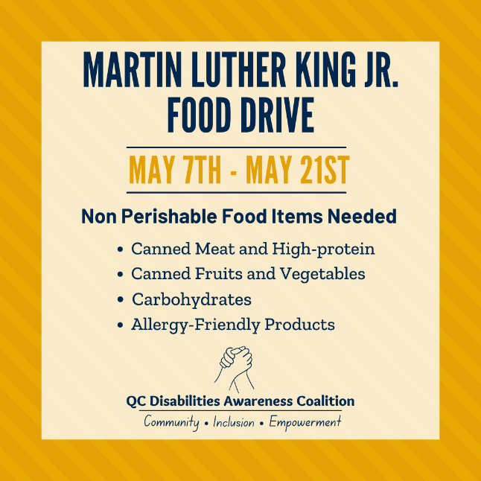
(Example) Informational Facebook Post (Example) Informational Instagram Post
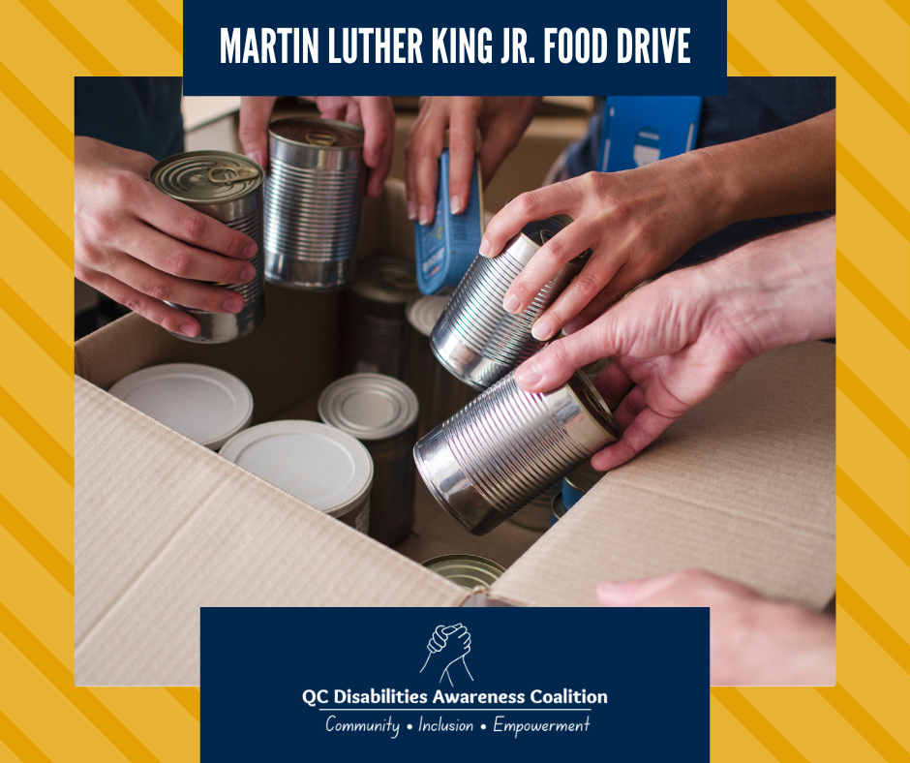 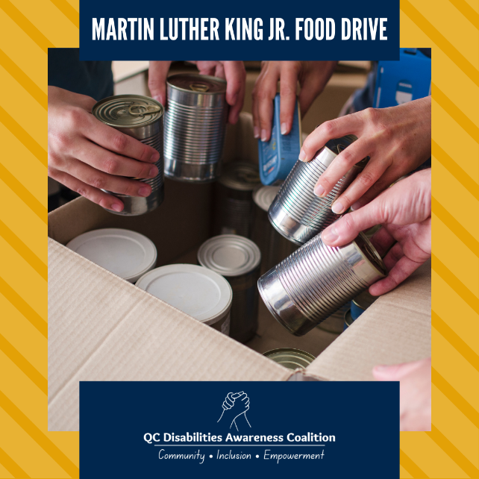
(Example) Facebook Frame for Post (Example) Instagram Frame for Post
If you would like us to combine the frames and photos for you, please feel free to email Travontae Williams at williamst@arcqca.org and he can combine select images for you.
To save the images, click on the link provided. When the image opens, right click and select ‘save as’. This should save the photo to your computer for future use.
Cover Image
We have also provided a cover photo that you can use on your organization’s Facebook page. Instead of each member’s logo, we utilized the coalition’s logo for the cover photo.
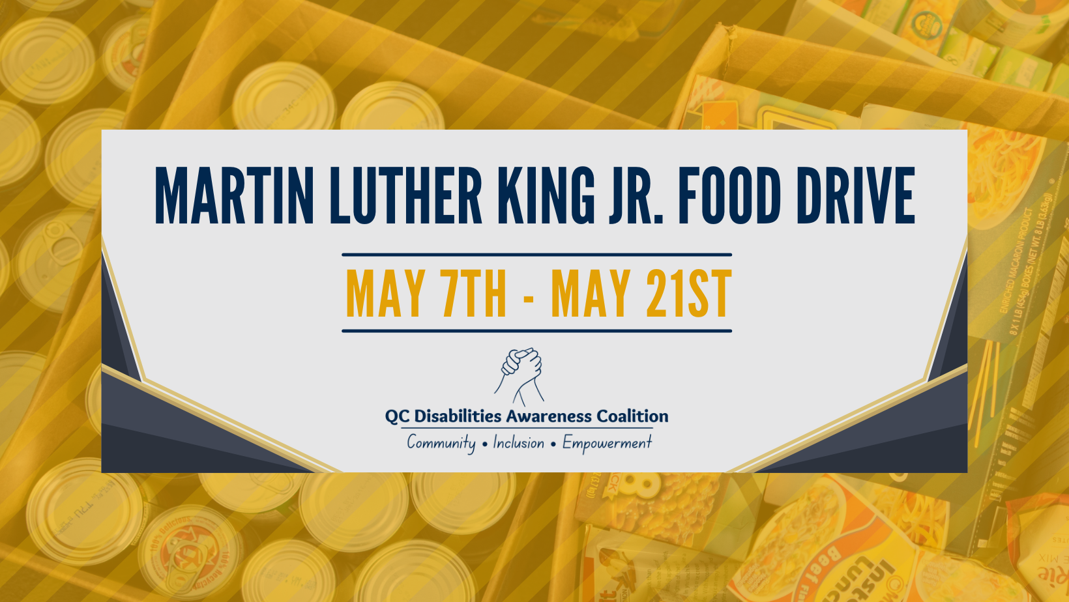
Drop-Off List
Below is the list of drop-off locations. It can also be viewed at https://arcqca.org/mlk-day-of-service/ and a QR Code linking to the direct site has been provided within this toolkit.
-QR Code-
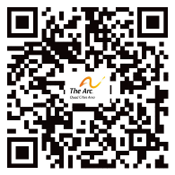
Illinois: Iowa:
Coal Valley | Bettendorf
- Robert R. Jones Public Library | - Bettendorf Hy-Vee
 | - Hand in Hand
Colona | - Bettendorf Public Library
- Colona Public Library
 | Davenport
East Moline | - Rockingham Rd. Hy-Vee
- East Moline Public Library | - West Kimberly Rd. Hy-Vee
- Individual Advocacy Group | - Northgate Hy-Vee
 | - Utica Ridge Hy-Vee
Milan | - West Locust St. Hy-Vee
- Milan Hy-Vee | - The River’s Edge (Davenport)
 | - Empowering Abilities
Moline | - Roosevelt Community Center
- Moline Public Library | - Davenport Community Center
- Hy-Vee on the Avenue | - Davenport Public Library Downtown
- Gigi’s Playhouse | - Davenport Public Library Fairmont
 | - Davenport Public Library Eastern
Rock Island | - Vander Veer Conservatory
- Rock Island Parks and Recreation | - Emeis Golf Course
- Arc Building | - Duck Creek Golf Course
- QC Flex | - Red Hawk Golf Course
- Rock Island Hy-Vee
- Rock Island Library Downtown
- Rock Island Library SW Branch
- Watts-Midtown Library
Silvis
- Silvis Hy-Vee
- Silvis Public Library
Fliers
Various fliers are available in different sizes and formats, including .png and .pdf. These fliers are designed for promotional purposes and information dissemination. Please feel free to print them off as needed. Hang the flier at your organization’s entrance to identify as a participating member.
PNG Format: (Download Link: https://arcqca.org/mlk-food-drive-partners/)
- Drop-Off Locations Flier (Slides)
- Full Page Flier
- Half Page Flier
- Quarter Page Flier
PDF Format (Download Link: https://arcqca.org/mlk-food-drive-partners/)
- Drop-Off Locations Flier (Listed)
- Full Page Flier
- Half Page Flier
- Quarter Page Flier

